|  |  |  |
| --- | --- | --- |
| Design an application in C++ using inheritance as per given requirements. Add required class and implementation . | | |
| Requirement Tag | Requirement Description | Comments |
| FSTR/01 | Application should create a model of a Person who can classified in one of the following categories with below given attributes. 1. Student - Institution, class 2. Working - Organization name, Designation 3. Non Working - Date since not working  Common attributes like name, age can be in base class Person |  |
| FSTR/02 | Each class to define appropriate constructors (with default and overloaded arguments) and destructors |  |
| FSTR/03 | Each class to define and implement a Display() method to display class members. |  |
| FSTR/04 | Create objects of different type Student, Working and Non-Working Person pin heap |  |
| FSTR/05 | Access objects using a base class pointer. Invoke the Display() of the object |  |
| FSTR/06 | Ensure that there are no memory leaks |  |

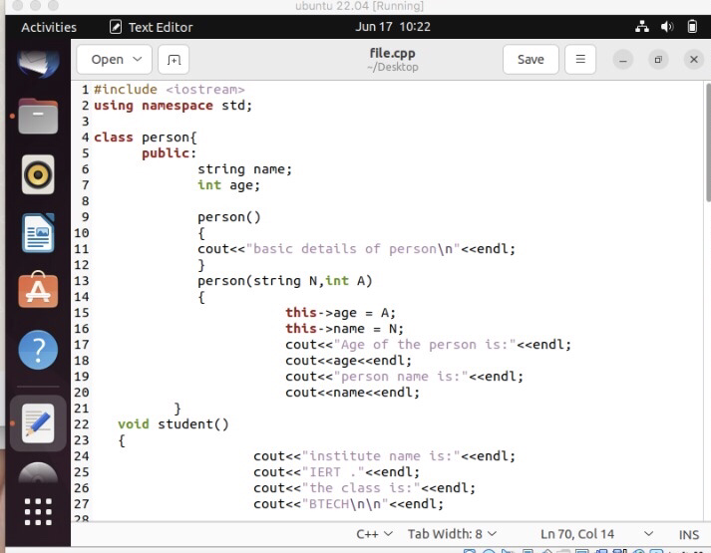

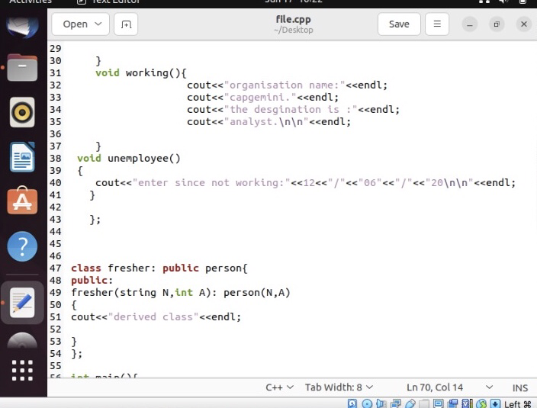

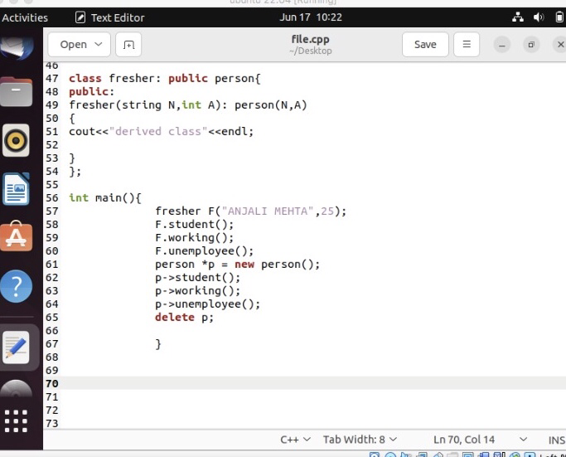

OUTPUT

